//Odd or Even

echo "Enter a num :"
read n
temp=$(($n%2))
if [ $temp -eq 0 ]
then
echo "It is even."
else
echo "It is odd."
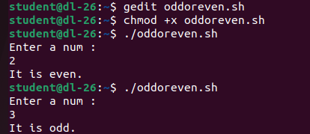
fi

